Title, Capitalize all Words Longer than four Letters. (Times New Roman, 14pt Bold, Space below 8pt)
Name Surname¹, Name Surname*², Name Surname^{1,2}. (Times New Roman, 11pt, Space below 6pt)
(1) Institution, Department, City, Country (Times New Roman, 10pt, Space below 6pt)
(2) Institution, Address, City, Country.
*Presenting author e-mail: email@address
Preferred Presentation type: (Select Oral or Poster)
One-line space.
Text of the abstract. Cite references, if any, as (Author et al., 2025) (Times New Roman, 11pt, Single line spacing, justified, space below 6pt)
You may include Figures and Tables. Leave one line before and after each Figure or Table. The corresponding captions should be placed below the Figure and above the Table.
One-line space.
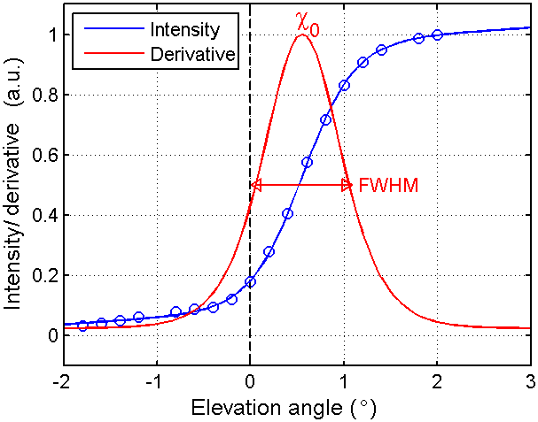
Figure 1: Caption of figure 1, centered. (Times New Roman, 10pt, Space below 6pt)
One-line space.
Acknowledgements (optional) (Times New Roman, Bold, 10pt, Space below 6pt)
Acknowledgement text. (Times New Roman, 10pt, Space below 6pt)

References (optional)
Author, X, Y. Author, Z. Author (2025), Title of paper, Journal, 40(5), doi:paperdoi.
Author, X., Y. Author, Z. Author (2025), Title of paper, DOAS Workshop 2020, Utrecht, The Netherlands.

